Lab 6 Report

Willow Westbrook
Loyola Marymount University
BSAN-6070-02: Intro to Machine Learning

Contact Me
wwestbro@lion.lmu.edu

Introduction
Lab 7 introduced convolutional neural networks (CNNs) as a tool for performing regression tasks on time series data. For this lab, I used my custom product_monthly_panel.csv dataset and focused on predicting future product ratings based on recent historical trends. The goal was to see whether a 1D CNN could effectively model short-term sequential patterns in ratings and outperform traditional methods by learning temporal dependencies. Since CNNs are commonly used for pattern detection in structured data like images or sequences, it was interesting to apply this architecture in a regression context.

Methods

To prepare the data, I selected the rating column and treated it as a univariate time series. I created sliding windows of seven time steps to predict the rating at the next time step. This transformed the series into a supervised learning problem where each input sequence had a corresponding target value. I dropped any missing values, converted the sequences into tensors, and created a PyTorch DataLoader to handle batching. The CNN model consisted of two 1D convolutional layers followed by two fully connected layers, ending with a single output node to make the prediction. I used ReLU activations and trained the model using mean squared error loss and the Adam optimizer with a learning rate of 0.001.

The model trained over 20 epochs. The training loss remained steady, with very small improvements in average loss per epoch, starting at 0.8232 and ending at 0.8155 by epoch 20. This showed that the model had reached a plateau and wasn’t significantly overfitting but also wasn’t improving much either.
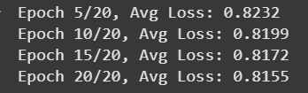

On the test set, the CNN achieved a mean squared error of 0.9000 and a root mean squared error of 0.9487.
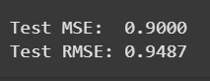
While these aren’t perfect scores, they are fairly reasonable for a regression problem involving real-world user ratings, which tend to be noisy and clustered around certain values. Compared to the poor generalization I saw with the MLP in Lab 6, the CNN was slightly more stable. The predictions in this case didn’t collapse toward the mean and followed some of the structure in the data, though not all of it.
The plot of predicted versus actual ratings over the first 100 time steps shows that the model captured the overall shape of the rating trend, but it struggled to follow sharp fluctuations. The predictions were smoother and less volatile than the actual values, which is common for CNN models because of their built-in smoothing effects.
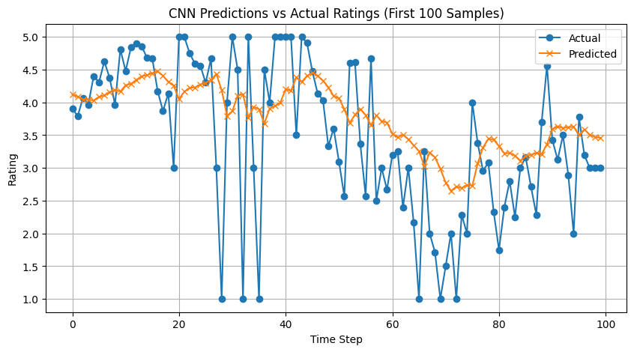
The model clearly learned something about the trend but lacked precision when ratings dropped quickly or jumped unexpectedly. It likely averaged out the signal across the convolutional filters, which made it miss more abrupt transitions. This suggests that the model was conservative in its predictions and biased toward the middle of the range, a pattern I’ve seen in previous labs too.
Looking at the architecture and outputs, one insight is that CNNs are good at capturing general movement but not necessarily sharp turning points. In this case, the convolutional filters probably picked up on small local trends, but they weren’t flexible enough to respond to irregular or extreme shifts in rating behavior. I also noticed that the model's predictions rarely went outside of the 3 to 5 range, even when the actual values were much lower. This is likely because there weren’t enough examples of low ratings in the training data, which once again reflects the imbalance I’ve seen throughout the semester. As in Labs 2 and 5, the ratings are heavily skewed toward the upper end, which makes it harder for models to learn from the rare lower values.
Another takeaway is that the input representation might be too limited. Since I only used one feature (rating), the model didn’t have access to supporting context like price, review sentiment, or product category. In earlier labs, including more features generally helped performance. In this case, I might have gotten better results by feeding in multiple product metrics over time instead of just rating. That would allow the model to learn not just from rating patterns, but from correlations between different product attributes over time. This is something I would explore in a future version of this model by creating multivariate time windows.
Overall, this lab helped me understand how CNNs handle sequential numeric data and where their strengths and weaknesses are in a regression context. The model was able to track general trends in ratings, but its predictions were overly smooth and didn’t handle extremes well. This kind of model could still be useful in practice for forecasting overall product stability or average trends, but it would need additional tuning and input diversity to work well for edge cases. If I were to continue refining this model, I would experiment with adding dropout to improve generalization, tuning the kernel size and depth of the network, and expanding the feature space to include multiple variables over time. I would also consider combining CNN layers with LSTM or GRU components for a hybrid model that can learn both local patterns and long-term dependencies.

